**Welcome to the NHS and Primary Care: A Guide for New Entrants to the UK**

**This leaflet:**

This leaflet is aimed at people who are new to the UK and have registered with an NHS GP practice.

It provides key information about what a GP practice is and how to navigate the practice to make the best use of its services.

**Introduction to the NHS**

Welcome to the National Health Service (NHS), the public healthcare system in the United Kingdom.

The NHS provides a wide range of health services to residents, including general practice (GP) services, hospital care, dental services, and more.

Most services are free at the point of use for UK residents.

**What is a GP Surgery?**

A GP surgery is your first point of contact for healthcare in the UK.

GPs (General Practitioners) are family doctors who deal with a wide range of health problems.

Register with a local GP surgery as soon as possible after arriving in the UK.

GP’s can provide medical advice, treatment, and refer you to specialist services if needed.

**How to Register with a GP**

Find a GP surgery close to where you live.

**Find a GP -** <https://www.nhs.uk/service-search/find-a-gp>

Once you've chosen a surgery, you'll need to fill in a registration form. These are usually available on:

* the NHS App
* the GP surgery's website
* the GP surgery's profile page on the NHS website (Find a GP)

You can also get a paper form from the surgery.

**Registering Children:**

Children under 16 need to be registered by their parent or guardian.

This usually means filling in a separate form.

You may also be asked to provide a form of ID to prove that you're their parent or guardian.

If you have a personal child health record (red book) from the birth of your child, it will help to provide this.

**First GP Surgery Contact**

After you register, you may be asked to be seen in a ‘new patient health checkup’ or registration appointment.

You will be asked about your medical history and any medication you take as well as having basic checks like blood pressure taken.

To support this process, please bring key medical information:

* Details of any chronic conditions or ongoing medical issues.
* A list of any medications you are currently taking, including doses.
* Information about any allergies or adverse reactions to medications.

If possible, have this information in English. This helps the clinicians to have a more informed picture of you.

**Translation Support**

If you need translation support during your GP surgery appointments, please inform the surgery when you register and book your appointments.

This allows reasonable adjustments to be made, such as adapting the length of the appointment and ensuring there is translation support for you and the clinician.

**Scope of Services in Primary Care**

GPs are the gateway to most other healthcare services.

GP surgeries are also a diverse team of administrative and clinical specialists, which can include GPs, practice pharmacists, physiotherapists, psychologists, and more.

GP surgeries provide:

* Diagnosis and treatment of common illnesses and medical conditions.
* Management of chronic conditions such as diabetes, asthma, and hypertension.
* Health education and preventive care, including vaccinations and health screenings.
* Referrals to specialist services and hospital care. Often, you need to discuss your concerns with a GP before being referred to a specialist.
* Support for mental health issues and referrals to counseling or psychiatric services if necessary.
* Maternity care and family planning services.

Access to further tests/investigations is through relaying your concerns with the clinicians you see. Remember, GPs in primary care do not have access to all the tests that a hospital doctor can order.

**Access and Making Appointments**

Most GP surgeries offer a range of ways to make an appointment, including:

* Visiting the surgery in person when it opens
* Telephone
* NHS app

Surgeries may also offer other modes of contact such as email and online consultations. If you have any difficulties accessing these options, please discuss this with the reception.

You can express your preference for the mode of appointments offered, which can include face-to-face, video calls, or telephone calls.

**GP Appointment Times**

GP appointment times are often limited to 10 minutes. To make the most of your appointment:

* Prepare a list of symptoms or questions you have.
* Bring any relevant medical information, including details of chronic conditions, past treatments, and any medications you are currently taking.
* Be ready to discuss your medical history, including any allergies or previous surgeries.

**Understanding Prescriptions**

A prescription is a note from your GP allowing you to get certain medicines.

Take your prescription to a pharmacy (also known as a chemist) to collect your medicine.

In some cases, there might be a charge for the prescription, but certain groups are exempt from these charges.

To find out more about access to free prescriptions, please see these links:

[https://faq.nhsbsa.nhs.uk/knowledgebase/article/KA-04005/en-us](https://gbr01.safelinks.protection.outlook.com/?url=https%3A%2F%2Ffaq.nhsbsa.nhs.uk%2Fknowledgebase%2Farticle%2FKA-04005%2Fen-us&data=05%7C02%7Cafsana.bhuiya%40nhs.net%7C87efaa26df9b4583aa5e08dcac8132e6%7C37c354b285b047f5b22207b48d774ee3%7C0%7C0%7C638574918123570502%7CUnknown%7CTWFpbGZsb3d8eyJWIjoiMC4wLjAwMDAiLCJQIjoiV2luMzIiLCJBTiI6Ik1haWwiLCJXVCI6Mn0%3D%7C0%7C%7C%7C&sdata=zl7sN2QWKv9PeYvyljcgotmXySfng0Vrv8RpYXFGbiY%3D&reserved=0)

[https://www.nhsbsa.nhs.uk/nhs-low-income-scheme](https://gbr01.safelinks.protection.outlook.com/?url=https%3A%2F%2Fwww.nhsbsa.nhs.uk%2Fnhs-low-income-scheme&data=05%7C02%7Cafsana.bhuiya%40nhs.net%7C87efaa26df9b4583aa5e08dcac8132e6%7C37c354b285b047f5b22207b48d774ee3%7C0%7C0%7C638574918123593687%7CUnknown%7CTWFpbGZsb3d8eyJWIjoiMC4wLjAwMDAiLCJQIjoiV2luMzIiLCJBTiI6Ik1haWwiLCJXVCI6Mn0%3D%7C0%7C%7C%7C&sdata=S%2FbyseiECRkFVSzZd9dsmFBdRiQkj9HW2ETxklNDk%2FE%3D&reserved=0)

**Electronic Prescription Service (EPS)**

The Electronic Prescription Service (EPS) allows your GP to send your prescription directly to your chosen pharmacy electronically.

This service can save you time as you don’t need to collect a paper prescription from your GP surgery.

**What is a Pharmacy (Chemist)?**

A pharmacy is a place where you can get medicines and health advice.

Pharmacists are trained professionals who can help with minor health problems, offer health advice, and provide over-the-counter medicines.

**Ordering Repeat Medication**

Most of the time, routine requests for ongoing medications, do not require you to speak to a doctor, they can be request this automatically.

Most surgeries offer written requests, email requests, NHS app requests, and sometimes your local pharmacy can request on your behalf.

Please familiarise yourself with these options and if you have any difficulties, flag this with the reception team.

**Your Records**

Many surgeries offer access to your records through an NHS-approved app.

Please register yourself onto the app through the surgery – please ask reception. The app enables you to order repeat medication, see your test results, and sometimes view consultation records.

For more information, visit [View Your GP Health Record](https://www.nhs.uk/nhs-services/gps/view-your-gp-health-record/)

**Other Important Services**

* **Walk-In Centres and Urgent Care Centres:** For non-life-threatening conditions that require urgent attention.
* **Accident & Emergency (A&E):** For serious or life-threatening conditions.
* **NHS 111:** A free telephone service for medical advice and information on local services.

**Further Information and Support**

For more information about the NHS and the services available to you, visit the NHS website at [www.nhs.uk](http://www.nhs.uk/) or speak to the staff at your GP surgery.

This map summaries where to go for medical help: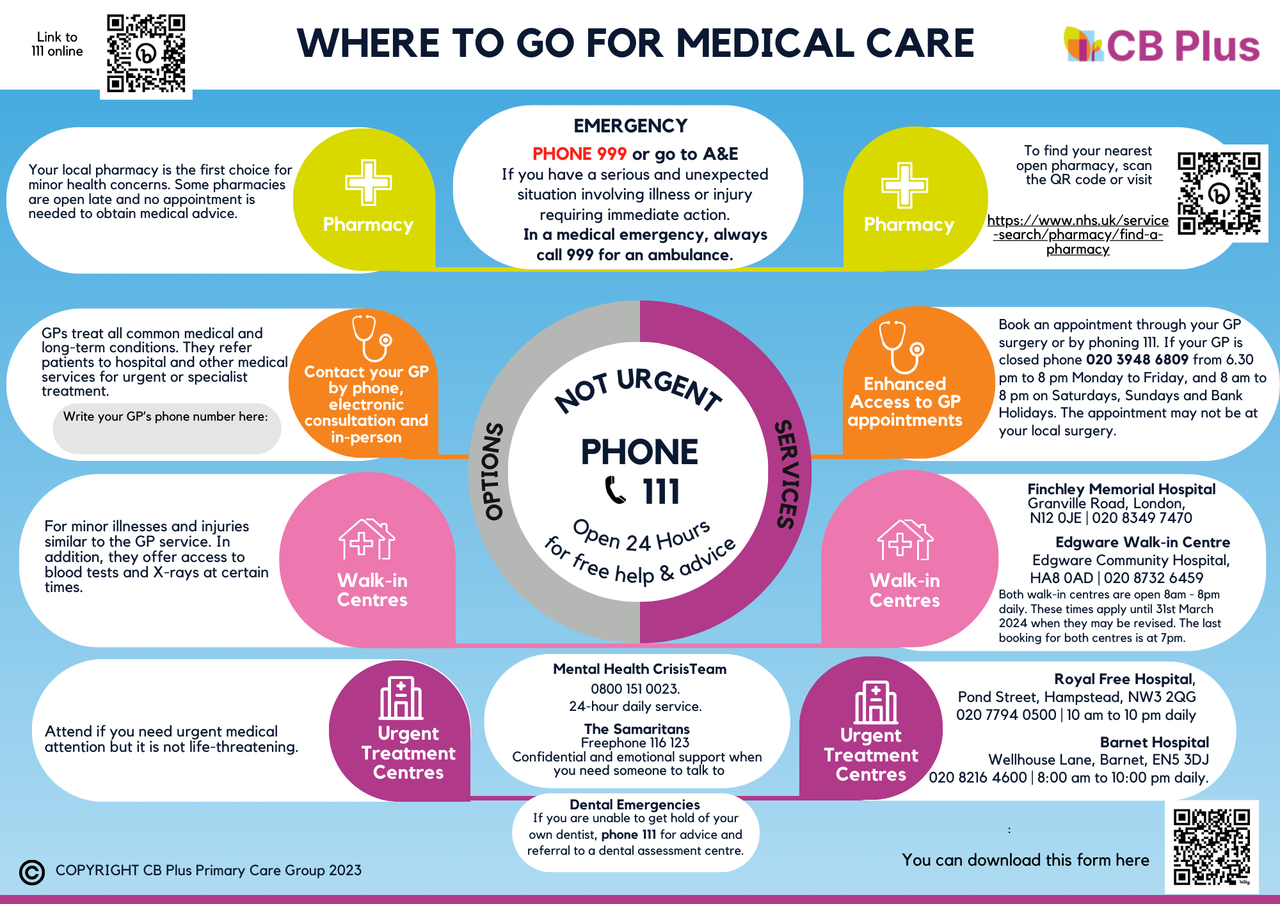

We hope this leaflet helps you navigate the NHS and make the most of the healthcare services available to you. Welcome to the UK!

**Contact Information**

* NHS Website: [www.nhs.uk](http://www.nhs.uk/)
* NHS 111: Dial 111 for non-emergency medical advice
* Local GP Surgery: [Insert local GP contact details]

**References**

* [Migrant Health Guide](https://www.gov.uk/government/collections/migrant-health-guide)
* [Doctors of the World: Supporting Medics Resources and Training](https://www.doctorsoftheworld.org.uk/what-we-stand-for/supporting-medics/resources-and-training/)
* [Doctors of the World: Translated Health Information](https://www.doctorsoftheworld.org.uk/translated-health-information/)
* [CB Plus Home - CB Plus](https://cbplus.org.uk/)